***The Node REPL***

**REPL**: Read Evaluation Print Loop.

It allows you to execute code in bite chunks just like what we did with the chrome developer tools console inside chrome.

Type **node** and press enter in hyper terminal.

>console.log(“Hey there!”);

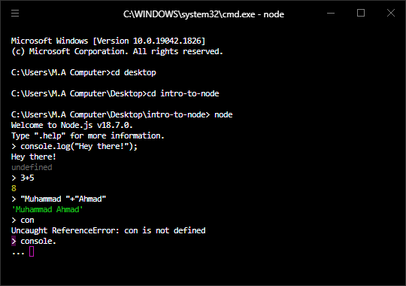

**.exit**  command to exit the node

**ctrl+d** is similar to .exit

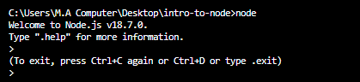

**cls Command:**

To clear the screen.